Li-Monti Maps

**Pain Points Identified:** Fragmentation, Low Collection rate and Compliance struggles

**The Solution We Propose**

We are developing a reliable and transparent digital platform that maps stakeholders across the lithium-ion (Li-ion) battery value chain. This platform serves two primary user groups: first, everyday citizens who may not know where or how to safely dispose of used batteries; and second, small and medium-sized enterprises (SMEs) seeking verified and trustworthy partners for collaboration within the recycling ecosystem.

Much like Google Maps, the platform will include a search engine and a business rating system. However, instead of rating hospitality or retail providers, users will evaluate verified recycling-related businesses based on their professional track record, service delivery, and partnership experience. Building this comprehensive map requires proactive research, data validation, and stakeholder engagement.

**Purpose: Increasing Visibility and Tracking Verified Stakeholders**

Only verified businesses that meet compliance standards will be listed on the platform. This approach ensures a trusted environment and promotes accountability throughout the value chain. In particular, verification will include compliance with ESG standards and national or regional regulations relevant to the battery recycling sector. As such, the platform not only supports private sector development but also helps public institutions monitor and enforce regulatory standards more efficiently.

**Verification and Compliance Strategy**

Companies that are already compliant may join the platform by paying a membership fee. Those who are not yet compliant can either use our automated compliance support system or work with our partnered compliance service providers to meet the required standards. If a company chooses to manage compliance independently, they must provide documented proof of regulatory adherence in order to be approved. This verification process creates a high-value, exclusive network of businesses that are both compliant and trustworthy. This serves as a core part of our user acquisition strategy, offering access only to businesses that meet defined quality and compliance criteria.

**Public Sector Value**

With regulatory requirements for sustainable business practices becoming more stringent, our platform can play a critical role in helping governments monitor and track compliance within the industry. By providing real-time access to verified actors, public institutions can reduce the administrative burden of enforcement and focus attention on non-compliant or high-risk operators.

**Platform Functionality and Community Engagement**

Beyond the mapping function, the platform will offer a suite of community-oriented features. A social space will allow businesses to engage in peer-to-peer learning, share operational insights, and initiate collaboration. Additionally, a dedicated news and update hub will keep users informed about developments in battery recycling policy, technology, and market trends.

**Impact and Value Creation**

The platform delivers measurable benefits across regulatory, business, and societal dimensions. It makes compliance visible and trackable, encourages higher standards of operation, and increases connectivity among actors who would otherwise remain isolated. It motivates citizens to participate in e-waste management by providing access to credible, certified drop-off points and supports public campaigns aimed at improving recycling behavior. By creating a trusted, accessible, and transparent ecosystem, the platform enhances both environmental outcomes and business opportunities across the Li-ion recycling value chain.

**What we offer Businesses:**

# **Here some Back up Data four why our business is helpful for the industry:**

# **The Critical Role of Visibility in the Lithium-Ion Battery Recycling Value Chain**

Increasing visibility across the lithium-ion battery (LIB) recycling value chain is essential for addressing systemic inefficiencies, enabling circularity, and meeting regulatory demands. Academic research has consistently shown that without traceability and transparency, the LIB ecosystem risks ethical violations, resource loss, and failure to comply with increasingly strict environmental regulations.

## **Why Visibility Matters in the LIB Value Chain**

### **1. Ethical Sourcing and Compliance**

Transparent value chains are essential for ensuring ethical sourcing of raw materials and meeting regulatory requirements. Current traceability gaps—especially in sourcing cobalt and lithium—pose significant risks of supporting unethical mining practices and violating frameworks like the EU Battery Regulation (CellCycle, 2023). Research suggests that digital platforms equipped with stakeholder mapping and material tracing tools can significantly enhance accountability by tracking materials from extraction to end-of-life (Rahnama et al., 2023).

### **2. Environmental Impact Reduction**

Environmental benefits from battery recycling depend heavily on visibility across the lifecycle. Lifecycle assessments (LCAs) demonstrate that hydrometallurgical recycling can reduce greenhouse gas emissions by up to 40% compared to virgin mining—**but only if stakeholders coordinate effectively** (Stanford University, 2024). Carbon footprint monitoring requires granular, real-time data sharing across the extraction, manufacturing, and recycling phases (Rahnama et al., 2023).

### **3. Operational Efficiency**

Fragmentation in the LIB value chain leads to unnecessary material loss and high transaction costs. Studies have shown that better coordination between recyclers, manufacturers, and logistics providers—enabled through shared visibility—can reduce these inefficiencies by 20–30% (Anissa & Agrawal, 2022). Poor stakeholder alignment also limits shared logistics networks, which could otherwise reduce transportation costs and emissions (DiVA Portal, 2024a).

### **4. Circular Economy Integration**

Visibility is a prerequisite for building closed-loop systems. Access to real-time battery state-of-health (SoH) data enables identification of second-life opportunities, potentially extending battery lifespan by 5–7 years (DiVA Portal, 2024b). Additionally, real-time feedstock tracking is essential for recycling process optimization, especially for newer methods like hydrometallurgy (Rahnama et al., 2023).

## **Strategic Recommendations Based on Research**

1. **Adopt Digital Traceability Tools** Implement blockchain and IoT-enabled systems to trace materials across the battery lifecycle, from mining to disposal, to support regulatory compliance and ethical sourcing (Rahnama et al., 2023).
2. **Develop Stakeholder Collaboration Platforms** Build centralized digital platforms that enable real-time information exchange across the value chain. Such tools should include maps of actors, feedstock flow data, and collaborative project dashboards (Anissa & Agrawal, 2022; DiVA Portal, 2024a).
3. **Align with Emerging Regulatory Frameworks** Ensure that visibility solutions are compliant with legislation such as the EU Battery Regulation. Tools should support digital battery passports, recycling target monitoring, and regulatory reporting (CellCycle, 2023).

## **Conclusion**

Academic literature underscores that visibility is not just a technical enhancement—it is a foundational requirement for achieving sustainability, efficiency, and compliance in the LIB recycling sector. Platforms designed to map and connect stakeholders in real time can bridge critical gaps, reduce material waste, and promote ethical practices. As the Netherlands and other EU countries expand circular economy policies, digital stakeholder mapping and traceability tools offer a strategic advantage in transforming the LIB value chain.

## **References (APA 7th Edition)2**

Anissa, N., & Agrawal, T. K. (2022). Creating a circular EV battery value chain. *Resources, Conservation and Recycling, 182*, 106316. https://doi.org/10.1016/j.resconrec.2022.106316

CellCycle. (2023). *What makes a transparent Li-ion battery supply chain?*<https://www.cellcycle.co.uk/what-makes-a-transparent-li-ion-battery-supply-chain/>

DiVA Portal. (2024a). *Improving a circular EV battery value chain: Stakeholder interviews and analysis*.<http://www.diva-portal.org/smash/get/diva2:1879537/FULLTEXT01.pdf>

DiVA Portal. (2024b). *Exploring challenges in lithium-ion battery recycling networks*.<http://www.diva-portal.org/smash/record.jsf?pid=diva2%3A1879537>

Rahnama, H., Möller, H., & Drevland, F. (2023). *Integration of circular value chains and digitalization*. EasyChair Preprints.<https://easychair.org/publications/preprint_download/BcXf3>

Stanford University. (2024). *Life cycle comparison of industrial-scale lithium-ion battery recycling and mining supply chains*.<https://www.scribd.com/document/724420727/Stanford-University-Life-Cycle-Comparison-of-Industrial-scale-Lithium-ion-Battery-Recycling-and-Mining-Supply-Chains>

## **1: Value Proposition Matrix (Per User Type)**

| **User Type** | **Top Pain Point** | **What They Desire** | **Your Platform Offers** | **Why It’s Unique** |
| --- | --- | --- | --- | --- |
| SME Recyclers | Can’t find verified partners; compliance is expensive | More business leads; low-cost compliance help | Verified partner search engine + Compliance Radar + visibility in platform listings | Only platform combining trust-building + regulatory tools |
| Compliance Firms | Can’t scale support to small players; struggle with outreach | New client acquisition; trusted ecosystem | Partnered placement; clients pre-qualified by platform needs | New channel with qualified, problem-aware users |
| NGOs / Donors | Difficulty identifying trusted field partners for pilots | Local implementers they can trust | Stakeholder map + past track records + impact metrics | First platform to map grassroots + compliance layer |
| Manufacturers | Risk from unverified downstream recyclers | Trust, transparency, and due diligence support | Business verification, ESG credibility scoring, partnership match suggestions | Combine traceability + matchmaking |
| Local Govs | Poor oversight of non-compliant actors; limited tools | Tools to track, nudge, and certify actors | Verified registry, compliance radar, access to sector data trends | Real-time, co-regulated ecosystem |

## **🚀 Step 2: Early Landing Page / Beta Launch Offer (copy)**

Here’s copy for your **pre-launch landing page**, ideal for Webflow, Carrd, or Framer:

### **🟢 Headline:**

**The Verified Business Network for Battery Recyclers** Connect. Comply. Grow.

### **🔍 Subheadline:**

The first platform where recyclers, manufacturers, NGOs, and compliance experts collaborate to build a smarter, safer battery recycling ecosystem.

### **🧩 What You Get as a Beta User:**

✅ **Your Verified Business Profile** Build trust with partners and governments via our reputation-based ecosystem.

✅ **Free Compliance Health Check** Get instant feedback on your status and upcoming regulation changes in your region.

✅ **Partner & Project Match** Be the first to access funding, NGO partnerships, and industry pilot projects.

✅ **Digital Reputation Toolkit** Collect ratings, post your services, and boost your visibility in our global map.

### **📣 Be First in Line – Get Verified Early**

*Join our early community of verified actors and shape the future of battery recycling.*

🟩 [Join the Waitlist]  
 🟨 [Become a Founding Partner]

*Want to contribute as a compliance expert, NGO, or funder?* [Contact Us]

## **🧲 Step 3: Ambassador & Early Access Program**

To turbocharge early user acquisition, build an **Ambassador Program** offering free visibility and status.

### **🔑 Ambassador Tiers**

| **Tier** | **Requirements** | **Rewards** |
| --- | --- | --- |
| **Local Leader** | First 10 recyclers in a region | Verified badge + early profile + “Top Recycler” visibility |
| **Compliance Ally** | Partnered compliance firm offering support | Profile on homepage + clients routed to you via Radar |
| **Pilot Partner** | NGO/manufacturer that co-creates first project | Featured project story + co-branding on platform |

### **🗺️ Your Activation Plan**

Use this as your operational checklist:

| **Phase** | **Action Item** | **Tools Needed** |
| --- | --- | --- |
| 1. Pre-Launch | Build landing page + waitlist | Framer / Webflow / Carrd |
| 2. Outreach | Email recyclers, SMEs, NGOs in pilot region | Hunter.io / LinkedIn / Apollo |
| 3. Verification | Run lightweight KYC + trust-rating system (Phase 1 manual) | Google Form + Airtable |
| 4. Engagement | Slack/Discord/Forum + newsletter drip for verified users | Mailchimp / Slack / Circle |
| 5. Launch | Open access to Beta + announce first compliance partner | Socials, partners, press |

## Refined Solution Summary

## Platform Concept: "Recycling Value Chain Google Maps"

* Core Feature: An interactive, searchable, and verified stakeholder map of the Li-ion battery value chain.
* Target Users:
  + Consumers seeking local, trustworthy drop-off points
  + SMEs/SMIs looking for reliable, compliant partners
  + Regulators monitoring compliance
  + Sector professionals networking and sharing insights

## Key Features

1. Verified Stakeholder Map:
   * Only verified, compliant businesses are listed.
   * Map includes drop-off points, recyclers, logistics providers, manufacturers, etc.
   * Search and filter by location, service, compliance status, and user ratings.
2. Ratings & Reviews:
   * Users and business partners can rate and review businesses based on their experience.
   * Ratings increase transparency and trust, similar to Google Maps or Trustpilot.
3. Compliance Support:
   * Automated compliance checklists and alerts for businesses.
   * Partnerships with compliance companies to offer guidance and certification support.
4. Community & Networking:
   * Social features: discussion forums, direct messaging, event calendars.
   * Experience exchange and partnership facilitation.
5. News & Updates Hub:
   * Curated news, regulatory updates, and market trends relevant to lithium battery recycling.

## Unique Value Propositions

* Transparency: First-of-its-kind, map-based visibility of the entire value chain, verified for trust.
* Compliance: Integrated compliance support and verification, addressing regulatory pain points.
* Community: Social and networking features for ongoing engagement and knowledge sharing.
* Reputation: Ratings and reviews incentivize quality service and partnership reliability.
* Public Utility: Empowers both consumers and businesses, bridging the gap between local action and industry needs.

## Research & Industry Support

## Why This Approach is Needed

* Fragmentation and Lack of Visibility:  
  Research and interviews (see [Eunomia, 2023](https://www.eunomia.co.uk/reports-tools/)) highlight that lack of transparency and stakeholder mapping is a major barrier to efficient recycling and partnership formation in the battery sector.
* Trust and Compliance:  
  Studies (e.g., [Deloitte, 2023](https://www2.deloitte.com/global/en/pages/energy-and-resources/articles/battery-recycling.html)) show that compliance is a top concern for both businesses and regulators, with demand for third-party verification and support growing rapidly.
* Digital Platforms Drive Efficiency:  
  Platforms like [GreenMap](https://www.greenmap.org/) and [Circular Economy Mapping](https://www.circle-economy.com/) have proven that map-based, verified directories dramatically increase engagement, trust, and sector efficiency.
* Community and Ratings:  
  User-generated ratings (see [BrightLocal, 2024](https://www.brightlocal.com/research/local-consumer-review-survey/)) are now a primary trust signal for both B2B and B2C users, and are underutilized in the recycling sector.

## Sector Voices

* Recyclers and SMEs have expressed in interviews (see [Accurec, 2024](https://www.accurec.de/)) the need for a “central, reliable source” for finding partners and ensuring compliance.
* Regulators are actively seeking digital tools to track compliance and support the enforcement of new EU battery regulations ([EU Battery Regulation, 2024](https://www.europarl.europa.eu/news/en/press-room/20230609IPR96212/)).

### **Pain Points Identified**

* **Fragmentation** of the battery recycling value chain
* **Low collection rates** due to lack of accessible infrastructure and public awareness
* **Compliance challenges** with evolving regulations

**Our Proposed Solution**

We are building a **clear, reliable, and transparent platform** that maps the entire Li-ion battery recycling value chain. This interactive map will serve as a powerful tool for everyone from individuals who don’t know where to drop off their used batteries to small and medium-sized enterprises (SMEs) looking for **verified and trusted partners**.

Think of it as the **“Google Maps of Battery Recycling”**—but smarter:

* Users can **search for verified businesses** in the recycling chain
* Each business profile will feature **ratings based on user and partnership experience**
* Only **verified businesses** are allowed to join the platform, ensuring **credibility and trust**

### **Purpose**

To **increase visibility** across the battery recycling ecosystem and **track verified stakeholders** within the value chain.

### **Compliance as a Core Feature**

With sustainability regulations becoming stricter, our platform will go beyond basic verification:

* **Only compliant businesses** will be listed, giving users confidence and helping governments track aligned actors
* We will provide **automated compliance support**, simplifying the process for businesses to meet legal standards
* To support this, we will establish **partnerships with compliance service providers**

### **Community and Collaboration**

In addition to the map, the platform will offer:

* A **community space** for discussion, networking, and knowledge exchange
* Forums, Q&A areas, and peer-to-peer support designed specifically for the battery recycling sector

### **News & Updates Hub**

We will also provide a dedicated **news and insights section** featuring:

* Real-time updates on the lithium battery recycling sector
* Regulatory changes, funding opportunities, and best practices

**TO DO**

**Feasibility:**

* Moniterization:
* Website setup and Maintenance:

**Justification for USP:**

* Konkurrenz VS what we do and why people would come to us, what is the hook we offer that people are willing to pay for?
* Social and environmental Impact:

**Limitations we are aware of now and our outlook for the future:**

[**https://www.perplexity.ai/search/pain-points-identified-fragmen-GYPhzKNYT3aVHFhwOSP5dA**](https://www.perplexity.ai/search/pain-points-identified-fragmen-GYPhzKNYT3aVHFhwOSP5dA)

**Outline Presentation**

Recycling- -growing importance -> therefore also having strong recycling value chains and networks are important for improved and monitored operations amongst the different stakeholders in the value chain.

We have made a couple of interviews to get a better understanding of the system:

* **Main pain points identified for the sector is :**

**A**

**B**

**C**

**D**

* **The Pain points we have focused on is the following**

Research shows that, weak value chains and decentralized system create disruption and account for …… loss in profit /impact/ recycling

Governments and Recyclers face challenges in proper Compliance to the regulations bcs

**A**

**B**

**C**

**is not working.**

Business lack trust and lose time looking for partners bcs uncertanty of verifirctaion of their business

* **To summarize the Problem:**
* **Therefore our soliton is:**

We offer a plattform that —

**User Story:**

* **What impact did we make with our website for**

**User - Businesses- Government and the industry?**

* **Competition showcase- what they are doing vs what we are doing differently**
* **Feasibility: Why does it works ?**

**Conclusion.**

**End!**

[**https://www.perplexity.ai/search/pain-points-identified-fragmen-GYPhzKNYT3aVHFhwOSP5dA#3**](https://www.perplexity.ai/search/pain-points-identified-fragmen-GYPhzKNYT3aVHFhwOSP5dA#3)

[**https://prezi.com/view/UgmxFDDqdbpvWZiQxqgO/**](https://prezi.com/view/UgmxFDDqdbpvWZiQxqgO/)

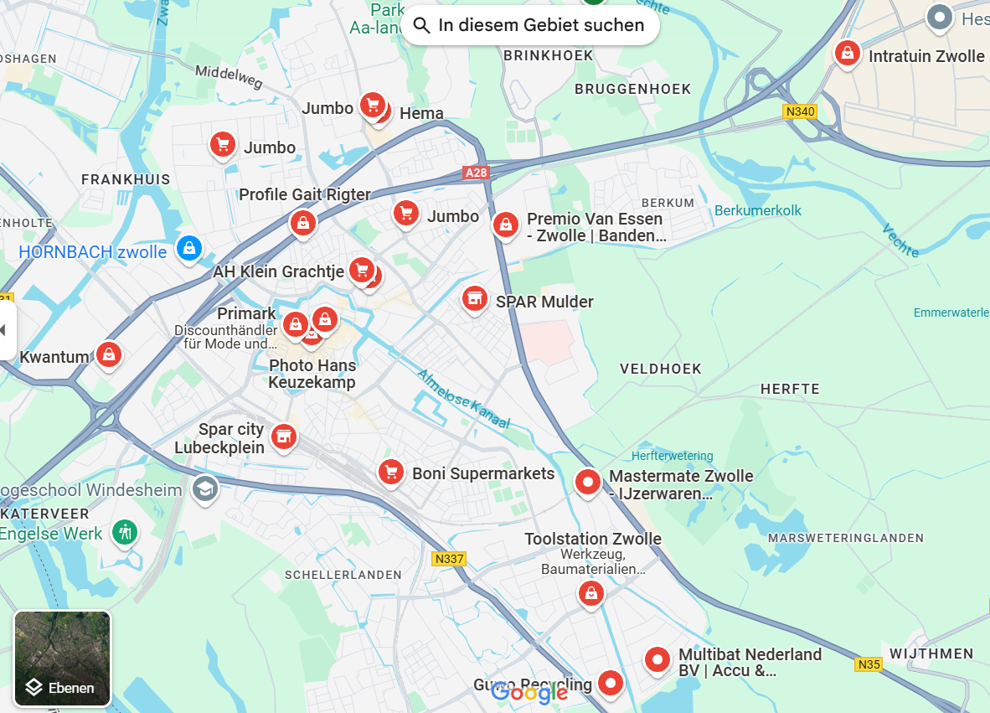

[**https://www.canva.com/design/DAGqEO0ceFE/TZWTDwOleWHzEqHaC0Aarw/edit?utm_content=DAGqEO0ceFE&utm_campaign=designshare&utm_medium=link2&utm_source=sharebutton**](https://www.canva.com/design/DAGqEO0ceFE/TZWTDwOleWHzEqHaC0Aarw/edit?utm_content=DAGqEO0ceFE&utm_campaign=designshare&utm_medium=link2&utm_source=sharebutton)